**Claim Statuses:** The Claim Statuses tab holds the list of eligible CNH claim statuses that are applied to claims in order to show what stage they are at in the claims process.

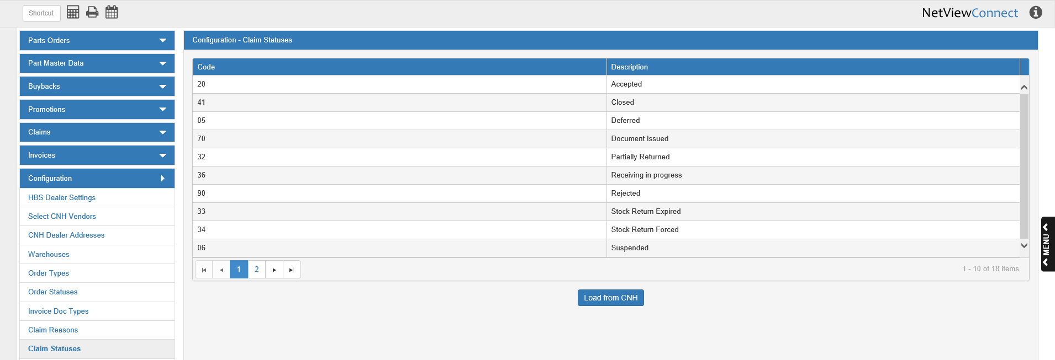

**Code:** This column holds the CNH claim status code.

**Description:** This column holds the status descriptions (Accepted, Closed, Deferred, etc.).

**Load from CNH:** When you first open the program, you will need to load the claim status list from CNH in order to have access to them on your claims. As your claims processing will be impeded without them, it is very important that you load the list before making any claims. After the button’s first use, the list will automatically reload every 30 days, but you may click the button at any time to receive the most updated version of the list.